**DATA ANALYTICS AND COMPARISON OF VARIOUS MODELS FOR PREDICTING APPOINTMENT NO-SHOW**

**HEALTH CARE SYSTEM - BRAZIL**

**Bala Tripura Sundari Padavala**

**Nichita Jamwale**

The following are the snapshots of the workflows performed in KNIME analytical tool.

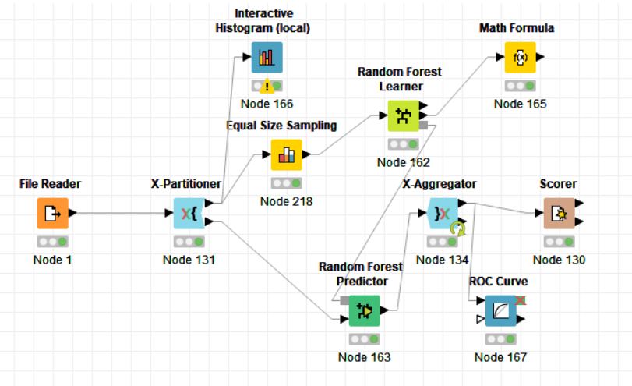

Fig 1: Random Forest using RUS

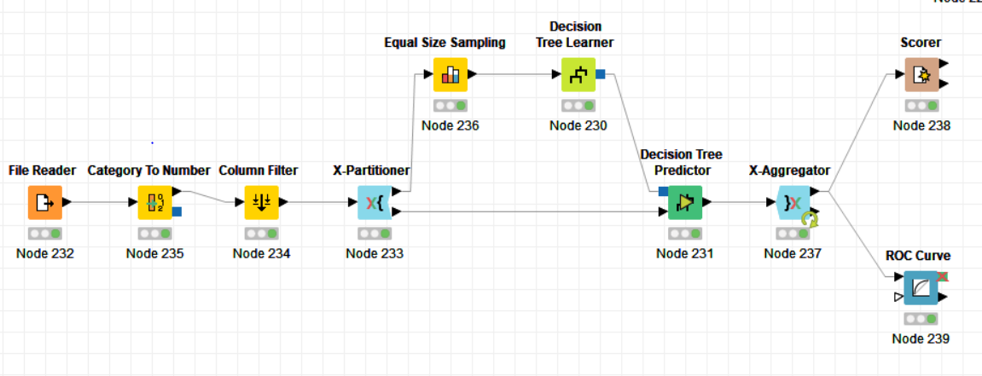

Fig 2: Decision Tress using RUS

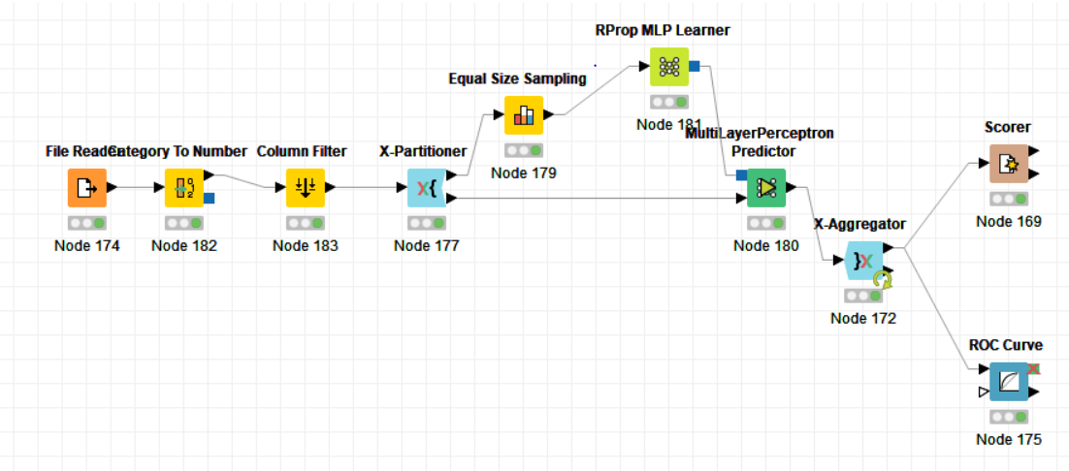

Fig 3: Artificial Neural Network(MLP)

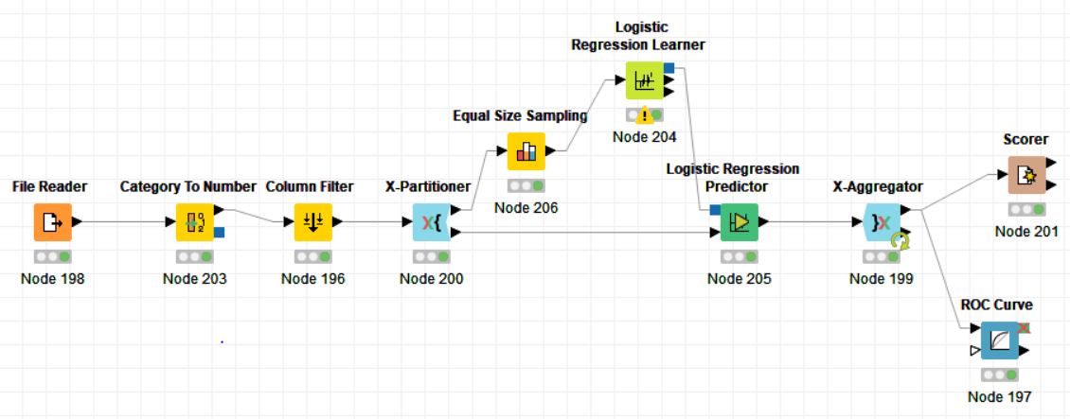

Fig 4: Logistic Regression using RUS

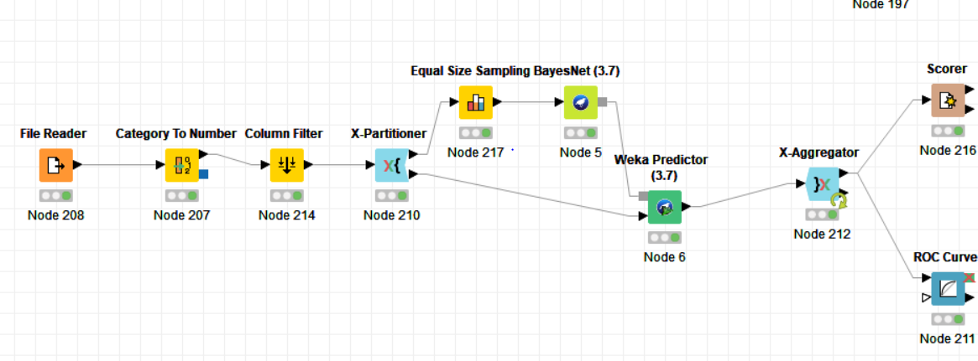

Fig 5: Bayesian Belief using RUS

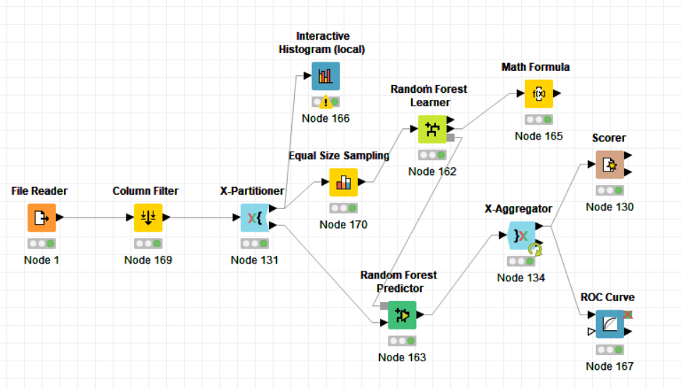

Fig 6: Random Forest using Genetic Algorithm

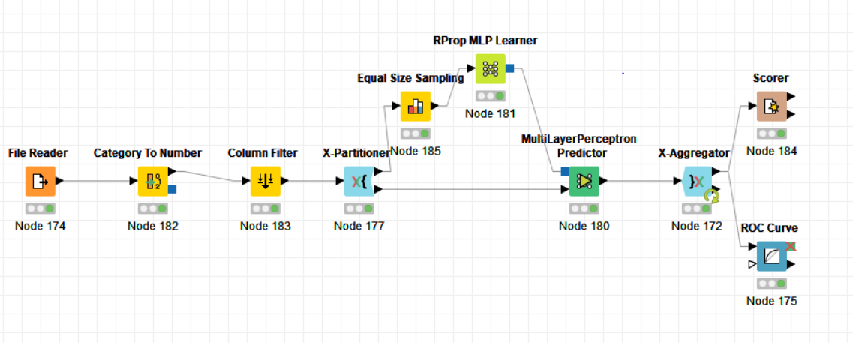

Fig 7: Artificial Neural Network using Genetic Algorithm

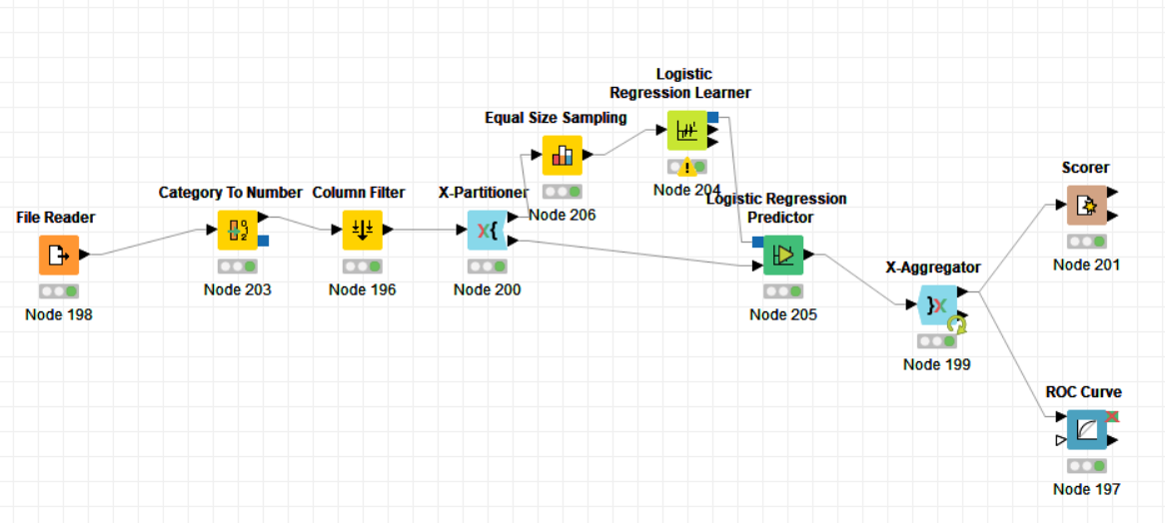

Fig 8: Logistic Regression using Genetic Algorithm

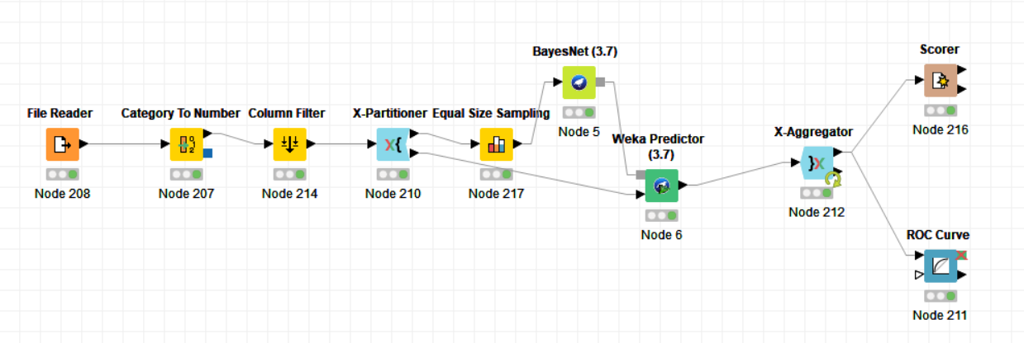

Fig 9: Bayesian Belief using Genetic Algorithm

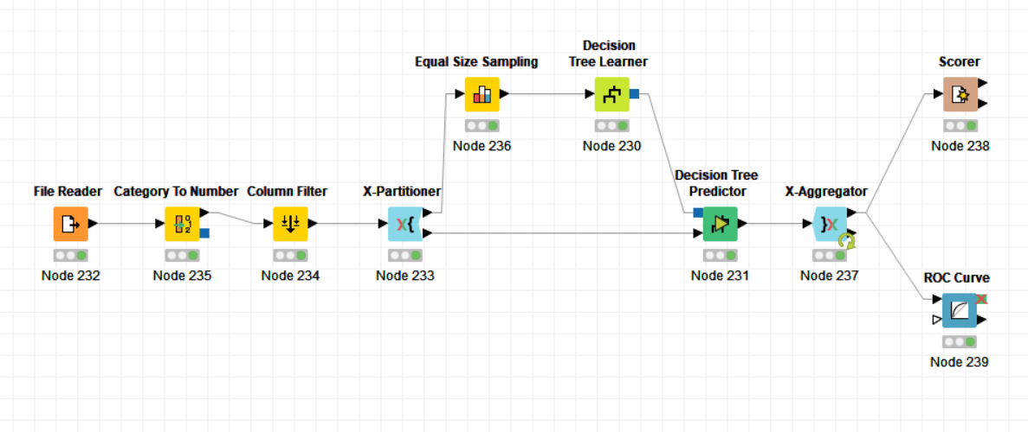

Fig 10: Decision Tree using Genetic Algorithm